**Codexchange: An Ai-Powered Code Translator Tool Using Palm’s Chat-bison**

|  |  |
| --- | --- |
| Details | Information |
| Date | 18 July 2024 |
| Team id | SWTID1720596651 |
| Project Name | CodeXchange: An AI-Powered Code Translator Tool using Palm's chat-bison-001 |
| Maximum Marks | 3 Marks |

**Define Problem Statements (AI-Powered Code Translator Tool Statement Template)**

#### **Problem Statements**

1. **Enable Effortless Code Translation**: Enable effortless code translation to facilitate migrating applications between various programming languages while preserving functionality and performance.
2. **Assist Developers in Effective Collaboration:** Assist developers in collaborating effectively by translating code snippets between different programming languages, ensuring readability and smooth integration.
3. **Code Reusability Across Projects**: Enhance code reusability by translating existing code for new projects, reducing development time and maintaining consistency.
4. **Improve Code Reliability**: Improve the reliability of translated code by addressing errors and bugs, ensuring it runs as expected and adheres to best practices.

**Problem Statements**

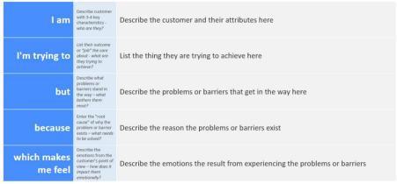

|  |  |  |  |  |  |  |  |
| --- | --- | --- | --- | --- | --- | --- | --- |
| **Problem Statement-1** | |  | | --- | | **I am**  **(Customer)** |  |  | | --- | |  | | **I am trying to** | **But** | **Because** | **Which makes me feel** |
| **PS-1** | A developer | Efficiently translate code snippets across different languages | It is challenging to ensure accuracy and maintain functionality across translations | I need to produce reliable code translations that can be seamlessly integrated into different projects | Frustrated and concerned about the quality and reliability of the translated code |
| **PS-2** | A development team member | Collaborate effectively by sharing translated code snippets | It is difficult to achieve readability and integration across languages | It is difficult to achieve readability and integration across languages | Empowered to work cohesively with team members, regardless of the programming languages they use |

***PS-1*** A developer who needs to translate code into another programming language for a co-worker. Efficiently translate code snippets across different languages. It is challenging to ensure accuracy and maintain functionality across translations. Confident in producing reliable code translations that can be seamlessly integrated into different projects.

***PS-2*** A development team member collaborating with peers using different programming languages. Collaborate effectively by sharing translated code snippets. It is difficult to achieve readability and integration across languages. Empowered to work cohesively with team members, regardless of the programming languages they use.